*To all Clergy, Churchwardens of vacant parishes and licensed Lay Workers*

March 2019

Dear Colleague

**Chrism Eucharist 2019**

I look forward to welcoming you all to this years’ service of Renewal of Commitment to Ministry as Deacons and Priests and Blessing of the Oils. I write to invite you to attend and hope that as many of the clergy and licensed Lay Workers as possible in the Diocese will come this year, and that we can meet up afterwards over refreshments.

The Diocesan Chrism Eucharist will be held on **Maundy Thursday, 18 April** at **11.00am** in the Cathedral. I will preside, preach and consecrate the oils. All deacons and priests are invited to renew their ordination vows.

Clergy are encouraged to robe in alb with white stole, or choir habit. Clergy should robe in the Crypt at the Cathedral and be ready to process at 10.45 am.

The oil will be blessed in large vessels. After the Eucharist these will be available in the Jesus Chapel and there will be ample opportunity for the filling of individual oil stocks. Clergy who intend to ask lay people to collect oil on their behalf are asked to provide them with written and signed authorisation on parish notepaper.

Before the Eucharist there will be priests available in the Jesus Chapel for quiet conversation, the ministry of reconciliation, or any other needs you may think appropriate. They will be available for clergy or laity from 10.15 am until 10.50 am. Please therefore observe a prayerful quietness prior to the Eucharist to facilitate this ministry.

After the Cathedral Eucharist the Dean and Chapter invite those present to share in refreshments in the Crypt. To enable proper provision to be made, please email [asstsecretary@bishopofblackburn.org.uk](mailto:asstsecretary@bishopofblackburn.org.uk) or return the slip overleaf to Jill Ghafoor at Bishop’s House no later than **29 March 2019.**

While this is an occasion for the clergy to gather with the bishops and their colleagues, we very much hope that lay people from our parishes will be encouraged to join us and support us as we renew our commitment to the Christian Faith as revealed in the Holy Scriptures and set forth in the Catholic Creeds, and to service in the ordained ministry.

There will also be a Chrism Eucharist at which Bishop Philip will preside and consecrate the oils, at Adlington St Paul on **Psalm Sunday, 14 April at 6.00pm**. Bishop Philip will write with further details to those who feel unable to participate in the Chrism Eucharist at the Cathedral.

We look forward to sharing in these services with you and very much hope that all clergy will feel able to come together with as many members of your congregations as possible.

With my prayers, as always

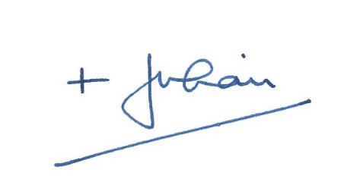

-------------------------------------------------------------------------------------------------------------------

I intend to be present at the Eucharist in Blackburn Cathedral, at 11.00am on Thursday 29 March at which Bishop Julian will preside and preach.

I will be accompanied by  members of my congregation

I intend to robe  I do not intend to robe

A total of  people intend to stay for refreshments

Name ………………………………………………..

Parish ………………………………………………….